**TESTING WITH PROFILES**

* When running an integration test, you’ll often want to test using the same configuration (or some subset thereof ) you’d use in production. But if your configuration references beans that are in profiles, you need a way to enable the appropriate profile when running those tests.
* Spring offers the @*ActiveProfiles* annotation to let you specify which profile(s) should be active when a test is run. Often it’s the development profile that you’ll want to activate during an integration test. For example, here’s a snippet of a test class that uses @*ActiveProfiles* to activate the *dev* profile:

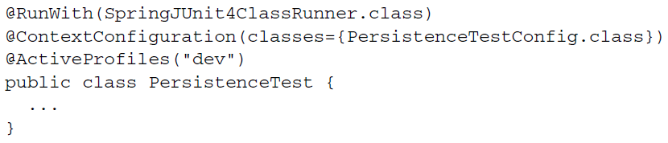

* Spring profiles are a great way to conditionally define where the condition is based on which profile is active. But Spring 4 offers a more general-purpose mechanism for conditional bean definitions where the condition is up to you.